Qbeast and C2S Integration
The core "Idea" for the integration is "The Self-Funding AI Roadmap."
The Logic:
- Qbeast drastically reduces the "Run" costs (Data Ops/Storage/Compute).
- C2S ReInvest™ (the framework) captures those specific savings and immediately reallocates them to fund "Grow" initiatives (AI/ML innovation), making the modernization effectively "free" or "self-funding."
The Qbeast + C2S Value Proposition
Target Audience: CDOs, CIOs, and Heads of Data Infrastructure.
Headline: The "Zero-Cost" Innovation Engine
Transform static cloud savings into active AI capital with Qbeast acceleration and the C2S ReInvest™ framework.
The Executive Summary
- Modern enterprises are trapped in the "Data Tax"—paying escalating costs for data storage and compute just to keep dashboards running, leaving zero budget for AI innovation.
- Qbeast + C2S breaks this cycle. Qbeast acts as the Efficiency Engine, optimizing data layout to slash compute bills by up to 70%.
- C2S ReInvest™ acts as the Capital Governor, instantly validating these savings and reallocating resources to high-value predictive modeling.
Why Qbeast? (The Engine)
Qbeast does not just query faster; it queries smarter.
- Performance Impact: 2x–6x faster query speeds on existing Data Lakes (Delta, Iceberg, Hudi) using multidimensional indexing (OTree) rather than brute-force scanning.
- Cost Impact: Reduces data scanned by 70%+, directly lowering compute costs (Databricks DBU/Snowflake credits).
- Sampling Superpower: Enables "Interactive Sampling"—allowing Data Scientists to train ML models on 1% of the data with 99% accuracy, speeding up AI epochs by 10x.
C2S ReInvest™ Integration (The Framework)
C2S Technologies wraps Qbeast’s raw performance in a strategic governance layer:
- Automated Savings Validation: The ReInvest™ dashboard tracks pre- vs. post-Qbeast compute spend.
- Budget Reallocation: Automatically flags "Saved Compute Units" and provisions them for R&D/AI workspaces.
- Implementation Assurance: C2S ensures Qbeast sits transparently on top of your existing Lakehouse without requiring a "Rip and Replace" of your current storage.
High-Level Architecture
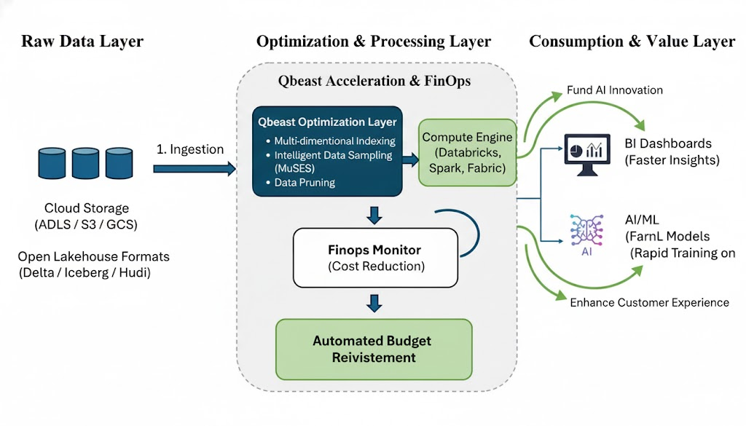

- Raw Data Layer: Existing S3/ADLS/GCS buckets (Delta/Parquet).
- Qbeast Optimization Layer: Indexes data (OTree) and manages sampling in-place.
- C2S ReInvest™ Governance:
  - FinOps Monitor: Tracks DBU reduction.
  - Performance Monitor: Tracks Query Latency.
- Consumption Layer: BI Dashboards (Tableau/PowerBI) run 10x faster; AI Models train on Qbeast Samples.
Key Differentiation
Feature | Standard Data Lake | Qbeast + C2S ReInvest™
Query Method | Full Scan (Slow & Expensive) | Sampling + Indexing (Fast & Cheap)
Cost Model | Costs grow with data volume | Costs decoupled from volume
AI Workflow | Slow training on massive datasets | Rapid training on weighted samples
Business Value | Cost Center | Self-Funding Innovation Source

Case Studies
Drafts based on real-world Qbeast capabilities to be validated with specific client data.
Case Study 1: The Retail "Black Friday" Simulator
Challenge: A global retailer struggled with real-time inventory queries during peak traffic. Dashboards took 4+ minutes to load, and cloud compute costs spiked 500% during events.
Solution: Implemented Qbeast to index the "Hot" inventory tables, allowing analysts to query samples of user behavior rather than raw logs.
Outcome:
- Query Acceleration: Dashboard load times dropped from 4 minutes to 3 seconds.
- Cost Reduction: Reduced compute spend by 65% by skipping irrelevant data blocks.
- ReInvest™ Impact: Savings were reallocated to fund a new "Price Elasticity" AI model pilot.
Case Study 2: High-Frequency IoT Analytics
Challenge: An automotive manufacturer ingesting TBs of sensor data daily could not analyze fleet health in real-time due to scanning costs.
Solution: Qbeast provided multidimensional indexing (Time + VehicleID + SensorType), allowing engineers to pinpoint specific error codes without scanning the whole lake.
Outcome:
- Data Skipped: 98% of data skipped per query.
- Efficiency: AI Model training time reduced by 60% using Qbeast sampling.
- Metric: Achieved sub-second latency on petabyte-scale datasets

